Geometry: Unit 10, Lesson 7
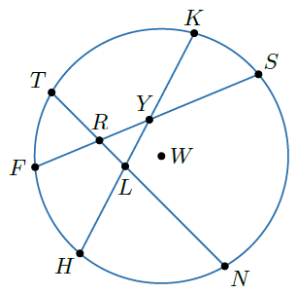
- Circle $W$ is shown with chords $\overline{TN}$, $\overline{KH}$, and $\overline{FS}$. What angle intersects $\hat{FT}$?

$$FRT$$

- What is the mean of $49$ and $76$?

$$62.5$$

- Given the equation $\frac{x+13}{2}=105$, what is the value of $x$?

$$197$$

